1. **Dependency Diagram**

Employee_num

Firstname

sex

Address

Lastname

Social number

Social num

Sex

Address

AUD_Regi_TMSTP

Phone_num

Order-num

Order_date

Order_ETA

Receiver_phone

Destination

Receiver name

Equp_num

brand

Manu_date

Merchandise_name

weight

heigh

Order_date

Tag_num

tamperature

humidity

Tag_ETA

Last_dect_TMSTP

safty

Steadable_num

Ip_address

address

Manu_date

Equp_num

AUD_Scan_TMSMTP

Tag_num

Steadable_num

AUD_Scan_TMSTP

Tag_num

1. **Logic ERD**

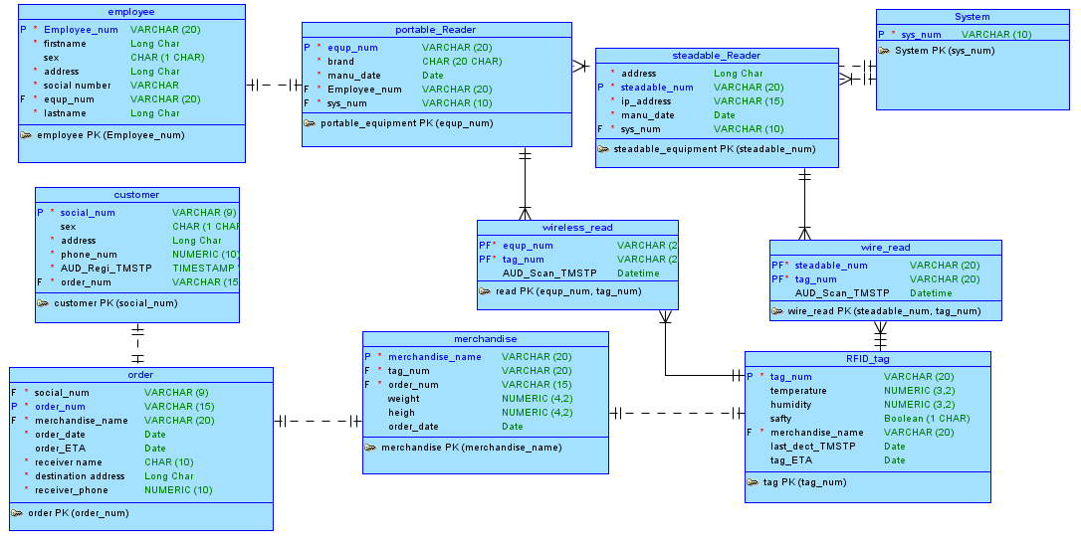

1. **The Relational Database Diagram.**

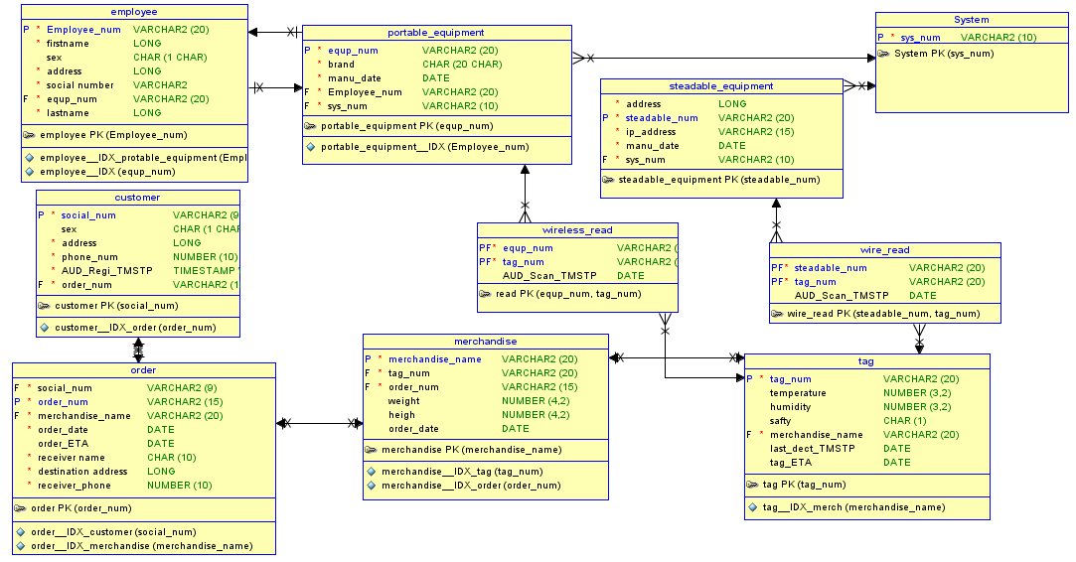

/****************/

/* DROP OBJECTS */

/****************/

DROP TABLE employee CASCADE CONSTRAINTS PURGE;

DROP TABLE customer CASCADE CONSTRAINTS PURGE;

DROP TABLE order CASCADE CONSTRAINTS PURGE;

DROP TABLE protable_equipment CASCADE CONSTRAINTS PURGE;

DROP TABLE steadable_equipment CASCADE CONSTRAINTS PURGE;

DROP TABLE system CASCADE CONSTRAINTS PURGE;

DROP TABLE wireless_read CASCADE CONSTRAINTS PURGE;

DROP TABLE wire_read CASCADE CONSTRAINTS PURGE;

DROP TABLE merchandise CASCADE CONSTRAINTS PURGE;

DROP TABLE tag CASCADE CONSTRAINTS PURGE;

DROP SEQUENCE SEQ_ employee;

DROP SEQUENCE SEQ_ pro_equip;

DROP SEQUENCE SEQ_ste_equip;

DROP SEQUENCE SEQ_ system;

DROP SEQUENCE SEQ_ wireless;

DROP SEQUENCE SEQ_ wire;

DROP SEQUENCE SEQ_merchan;

DROP SEQUENCE SEQ_ tag;

1. **The SQL DDL script**

-- Operator Oracle SQL Developer Data Modeler 3.1.4.710

-- Time: 2013-04-03 00:49:13 EDT

-- Location: Oracle Database 11g

-- Type: Oracle Database 11g

CREATE TABLE System

(

sys_num VARCHAR2 (10) NOT NULL

)

;

COMMENT ON TABLE System IS 'System info: other search engine'

;

ALTER TABLE System

ADD CONSTRAINT "System PK" PRIMARY KEY ( sys_num ) ;

CREATE TABLE customer

(

social_num VARCHAR2 (9) NOT NULL ,

sex CHAR (1 CHAR) ,

address LONG NOT NULL ,

phone_num NUMBER (10) NOT NULL ,

AUD_Regi_TMSTP TIMESTAMP WITH LOCAL TIME ZONE NOT NULL

)

;

COMMENT ON TABLE customer IS 'This entity is constitute by sender and receiver'

;

COMMENT ON COLUMN customer.social_num IS 'social security number'

;

COMMENT ON COLUMN customer.address IS 'where the customer live'

;

COMMENT ON COLUMN customer.phone_num IS 'Cellphone numer'

;

ALTER TABLE customer

ADD CONSTRAINT "customer PK" PRIMARY KEY ( social_num ) ;

CREATE TABLE employee

(

Employee_num VARCHAR2 (20) NOT NULL ,

firstname LONG NOT NULL ,

lastname LONG NOT NULL ,

sex CHAR (1 CHAR) ,

address LONG NOT NULL ,

"social number" VARCHAR2 NOT NULL ,

equp_num VARCHAR2 (20) NOT NULL

)

;

COMMENT ON TABLE employee IS 'employe could use portable equipment to supervise merchandise through RFID tag'

;

COMMENT ON COLUMN employee.Employee_num IS 'identify each employee, this is unique

'

;

COMMENT ON COLUMN employee.address IS 'address of emplyee'

;

COMMENT ON COLUMN employee."social number" IS 'social security number '

;

CREATE UNIQUE INDEX employee__IDX ON employee

(

equp_num ASC

)

;

ALTER TABLE employee

ADD CONSTRAINT "employee PK" PRIMARY KEY ( Employee_num ) ;

CREATE TABLE merchandise

(

merchandise_name VARCHAR2 (20) NOT NULL ,

tag_num VARCHAR2 (20) NOT NULL ,

order_num VARCHAR2 (15) NOT NULL ,

weight NUMBER (4,2) ,

heigh NUMBER (4,2) ,

order_date DATE

)

;

COMMENT ON TABLE merchandise IS 'sent by customer(sender). Monitering all the time during transportation.'

;

COMMENT ON COLUMN merchandise.merchandise_name IS 'merchandise number'

;

COMMENT ON COLUMN merchandise.tag_num IS 'FKey'

;

COMMENT ON COLUMN merchandise.order_num IS 'FKey

'

;

COMMENT ON COLUMN merchandise.weight IS 'norm of merchandise'

;

COMMENT ON COLUMN merchandise.heigh IS 'norm of merchandise'

;

COMMENT ON COLUMN merchandise.order_date IS 'when the order is created'

;

CREATE UNIQUE INDEX merchandise__IDX_tag ON merchandise

(

tag_num ASC

)

;

CREATE UNIQUE INDEX merchandise__IDX_order ON merchandise

(

order_date ASC

)

;

ALTER TABLE merchandise

ADD CONSTRAINT "merchandise PK" PRIMARY KEY ( merchandise_name ) ;

CREATE TABLE "order"

(

social_num VARCHAR2 (9) NOT NULL ,

order_num VARCHAR2 (15) NOT NULL ,

merchandise_name VARCHAR2 (20) NOT NULL ,

order_date DATE NOT NULL ,

order_ETA DATE ,

"receiver name" CHAR (10) NOT NULL ,

"destination address" LONG NOT NULL ,

receiver_phone NUMBER (10) NOT NULL

)

;

COMMENT ON TABLE "order" IS 'Customer(sender) creates order, one order can have several merchandises to send.'

;

COMMENT ON COLUMN "order".social_num IS 'PKey'

;

COMMENT ON COLUMN "order".order_num IS 'the number of order list'

;

COMMENT ON COLUMN "order".merchandise_name IS 'PKey'

;

COMMENT ON COLUMN "order"."receiver name" IS 'receiver customer name'

;

COMMENT ON COLUMN "order"."destination address" IS 'address of receiver'

;

CREATE UNIQUE INDEX order__IDX_customer ON "order"

(

social_num ASC

)

;

CREATE UNIQUE INDEX order__IDX_merchandise ON "order"

(

merchandise_name ASC

)

;

ALTER TABLE "order"

ADD CONSTRAINT "order PK" PRIMARY KEY ( order_num ) ;

CREATE TABLE portable_equipment

(

equp_num VARCHAR2 (20) NOT NULL ,

brand CHAR (20 CHAR) NOT NULL ,

manu_date DATE NOT NULL ,

sys_num VARCHAR2 (10) NOT NULL ,

Employee_num VARCHAR2 (20) NOT NULL ,

)

;

COMMENT ON TABLE portable_equipment IS 'reader equipment has two kinds: portable equipment and steadable equipment'

;

COMMENT ON COLUMN portable_equipment.equp_num IS 'equp_num is unique number of portable equipment'

;

COMMENT ON COLUMN portable_equipment.brand IS 'by which company manufactured'

;

COMMENT ON COLUMN portable_equipment.manu_date IS 'date when manufactated'

;

COMMENT ON COLUMN portable_equipment.sys_num IS 'FKey'

;

COMMENT ON COLUMN portable_equipment.Employee_num IS 'FKey'

;

CREATE UNIQUE INDEX portable_equipment__IDX_sys ON portable_equipment

(

sys_num ASC

)

;

CREATE UNIQUE INDEX portable_equipment__IDX_emp ON portable_equipment

(

Employee_num ASC

)

;

ALTER TABLE portable_equipment

ADD CONSTRAINT "portable_equipment PK" PRIMARY KEY ( equp_num ) ;

CREATE TABLE steadable_equipment

(

address LONG NOT NULL ,

steadable_num VARCHAR2 (20) NOT NULL ,

ip_address VARCHAR2 (15) NOT NULL ,

manu_date DATE NOT NULL ,

sys_num VARCHAR2 (10) NOT NULL ,

)

;

COMMENT ON TABLE steadable_equipment IS 'reader equipment has two kinds: portable equipment and steadable equipment'

;

COMMENT ON COLUMN steadable_equipment.address IS 'address where it located

'

;

COMMENT ON COLUMN steadable_equipment.ip_address IS 'special IP address of steadable equipment'

;

COMMENT ON COLUMN steadable_equipment.manu_date IS 'when this equipment manufactured'

;

CREATE INDEX steadable_equipment__IDX_sys ON steadable_equipment

(

sys_num ASC

)

;

ALTER TABLE steadable_equipment

ADD CONSTRAINT "steadable_equipment PK" PRIMARY KEY ( steadable_num ) ;

CREATE TABLE tag

(

tag_num VARCHAR2 (20) NOT NULL ,

temperature NUMBER (3,2) ,

humidity NUMBER (3,2) ,

safty CHAR (1) ,

merchandise_name VARCHAR2 (20) NOT NULL ,

last_dect_TMSTP DATE ,

tag_ETA DATE

)

;

COMMENT ON TABLE tag IS 'RFID tag, contains a lot of safty info. Tags will be connected when passes through the steadable equipment or scaned by portable equipment which is used by employee.'

;

COMMENT ON COLUMN tag.tag_num IS 'special number of RFID tag'

;

COMMENT ON COLUMN tag.temperature IS 'detection info from sensor'

;

COMMENT ON COLUMN tag.humidity IS 'detection info from sensor'

;

COMMENT ON COLUMN tag.safty IS 'detection info from sensor'

;

COMMENT ON COLUMN tag.merchandise_name IS 'detection info from sensor'

;

COMMENT ON COLUMN tag.tag_ETA IS 'estimated time of arrival'

;

CREATE UNIQUE INDEX tag__IDX_merch ON tag

(

merchandise_name ASC

)

;

ALTER TABLE tag

ADD CONSTRAINT "tag PK" PRIMARY KEY ( tag_num ) ;

CREATE TABLE wire_read

(

steadable_num VARCHAR2 (20) NOT NULL ,

tag_num VARCHAR2 (20) NOT NULL

)

;

ALTER TABLE wire_read

ADD CONSTRAINT "wire_read PK" PRIMARY KEY ( steadable_num, tag_num ) ;

CREATE TABLE wireless_read

(

equp_num VARCHAR2 (20) NOT NULL ,

tag_num VARCHAR2 (20) NOT NULL

)

;

ALTER TABLE wireless_read

ADD CONSTRAINT "read PK" PRIMARY KEY ( equp_num, tag_num ) ;

ALTER TABLE wire_read

ADD CONSTRAINT Relation_11 FOREIGN KEY

(

tag_num

)

REFERENCES tag

(

tag_num

)

ON DELETE CASCADE

;

ALTER TABLE wireless_read

ADD CONSTRAINT Relation_5 FOREIGN KEY

(

tag_num

)

REFERENCES tag

(

tag_num

)

ON DELETE CASCADE

;

ALTER TABLE steadable_equipment

ADD CONSTRAINT Relation_7 FOREIGN KEY

(

sys_num

)

REFERENCES System

(

sys_num

)

ON DELETE CASCADE

;

ALTER TABLE employee

ADD CONSTRAINT employee_portable_equipment_FK FOREIGN KEY

(

equp_num

)

REFERENCES portable_equipment

(

equp_num

)

ON DELETE CASCADE

;

ALTER TABLE portable_equipment

ADD CONSTRAINT manage FOREIGN KEY

(

Employee_num

)

REFERENCES employee

(

Employee_num

)

ON DELETE CASCADE

;

ALTER TABLE merchandise

ADD CONSTRAINT notify FOREIGN KEY

(

tag_num

)

REFERENCES tag

(

tag_num

)

ON DELETE CASCADE

;

ALTER TABLE tag

ADD CONSTRAINT notify FOREIGN KEY

(

merchandise_name

)

REFERENCES merchandise

(

merchandise_name

)

ON DELETE CASCADE

;

ALTER TABLE merchandise

ADD CONSTRAINT "order" FOREIGN KEY

(

order_num

)

REFERENCES "order"

(

order_num

)

ON DELETE CASCADE

;

ALTER TABLE "order"

ADD CONSTRAINT "order" FOREIGN KEY

(

social_num

)

REFERENCES customer

(

social_num

)

ON DELETE CASCADE

;

ALTER TABLE "order"

ADD CONSTRAINT orderv1 FOREIGN KEY

(

merchandise_name

)

REFERENCES merchandise

(

merchandise_name

)

ON DELETE CASCADE

;

ALTER TABLE wireless_read

ADD CONSTRAINT readv1 FOREIGN KEY

(

equp_num

)

REFERENCES portable_equipment

(

equp_num

)

ON DELETE CASCADE

;

ALTER TABLE portable_equipment

ADD CONSTRAINT support FOREIGN KEY

(

sys_num

)

REFERENCES System

(

sys_num

)

ON DELETE CASCADE

;

ALTER TABLE wire_read

ADD CONSTRAINT wire_Read FOREIGN KEY

(

steadable_num

)

REFERENCES steadable_equipment

(

steadable_num

)

ON DELETE CASCADE

;

CREATE OR REPLACE VIEW V_System ( sys_num )

AS SELECT

sys_num

FROM

System ;

CREATE OR REPLACE VIEW V_customer ( social_num,

sex,

address,

phone_num )

AS SELECT

social_num,

sex,

address,

phone_num

FROM

customer ;

CREATE OR REPLACE VIEW V_employee ( Employee_num,

firstname,

lastname,

sex,

address,

"social number",

equp_num )

AS SELECT

Employee_num,

firstname,

lastname,

sex,

address,

"social number",

equp_num

FROM

employee ;

CREATE OR REPLACE VIEW V_merchandise ( merchandise_name,

tag_num,

order_num,

weight,

heigh,

order_date,

ETA )

AS SELECT

merchandise_name,

tag_num,

order_num,

weight,

heigh,

order_date,

ETA

FROM

merchandise ;

CREATE OR REPLACE VIEW V_order ( social_num,

order_num,

merchandise_name,

order_date,

order_ETA,

"receiver name",

"destination address",

receiver_phone )

AS SELECT

social_num,

order_num,

merchandise_name,

order_date,

order_ETA,

"receiver name",

"destination address",

receiver_phone

FROM

"order" ;

CREATE OR REPLACE VIEW V_portable_equipment ( equp_num,

brand,

manu_date,

sys_num,

Employee_num )

AS SELECT

equp_num,

brand,

manu_date,

sys_num,

Employee_num

FROM

portable_equipment ;

CREATE OR REPLACE VIEW V_steadable_equipment ( address,

steadable_num,

ip_address,

manu_date,

sys_num )

AS SELECT

address,

steadable_num,

ip_address,

manu_date,

sys_num

FROM

steadable_equipment ;

CREATE OR REPLACE VIEW V_tag ( tag_num,

temperature,

humidity,

safty,

merchandise_name )

AS SELECT

tag_num,

temperature,

humidity,

safty,

merchandise_name

FROM

tag ;

CREATE OR REPLACE VIEW V_wire_read ( steadable_num,

tag_num )

AS SELECT

steadable_num,

tag_num

FROM

wire_read ;

CREATE OR REPLACE VIEW V_wireless_read ( equp_num,

tag_num )

AS SELECT

equp_num,

tag_num

FROM

wireless_read ;

CREATE OR REPLACE TRIGGER manu_date

BEFORE INSERT

ON protable_equipment

for each row

BEGIN

:new.manu_date := sysdate;

END;

/

CREATE OR REPLACE TRIGGER manu_date

BEFORE INSERT

ON steadable_equipment

for each row

BEGIN

:new.manu_date:= sysdate;

END;

/

CREATE OR REPLACE TRIGGER AUD_Regi_TMSTP

BEFORE INSERT

ON customer

for each row

BEGIN

:new.AUD_Regi_TMSTP := sysdate;

END;

/

CREATE OR REPLACE TRIGGER order_ETA

BEFORE UPLOAD

ON order

for each row

BEGIN

SELECT ETA INTO v_order FROM tag;

:new.order_ETA := ETA;

END;

/

/******************/

/* CREATE SEQUNCES*/

/******************/

---- These sequences are used to create primary keys of the table

---- and work as sequence generators. They begin with 1 and with

---- each record insert keep increasing with 1.

CREATE SEQUENCE SEQ_ employee

INCREMENT BY 1

START WITH 1;

CREATE SEQUENCE SEQ_ pro_equip

INCREMENT BY 1

START WITH 1;

CREATE SEQUENCE SEQ_ ste_equip

INCREMENT BY 1

START WITH 1;

CREATE SEQUENCE SEQ_ system

INCREMENT BY 1

START WITH 1;

CREATE SEQUENCE SEQ_ wireless

INCREMENT BY 1

START WITH 1;

CREATE SEQUENCE SEQ_ wire

INCREMENT BY 1

START WITH 1;

CREATE SEQUENCE SEQ_ merchan

INCREMENT BY 1

START WITH 1;

CREATE SEQUENCE SEQ_ tag

INCREMENT BY 1

START WITH 1;

-- Oracle SQL Developer Data Modeler 概要报告:

--

-- CREATE TABLE 10

-- CREATE INDEX 9

-- ALTER TABLE 23

-- CREATE VIEW 10

-- CREATE PACKAGE 0

-- CREATE PACKAGE BODY 0

-- CREATE PROCEDURE 0

-- CREATE FUNCTION 0

-- CREATE TRIGGER 4

-- ALTER TRIGGER 0

-- CREATE STRUCTURED TYPE 0

-- CREATE COLLECTION TYPE 0

-- CREATE CLUSTER 0

-- CREATE CONTEXT 0

-- CREATE DATABASE 0

-- CREATE DIMENSION 0

-- CREATE DIRECTORY 0

-- CREATE DISK GROUP 0

-- CREATE ROLE 0

-- CREATE ROLLBACK SEGMENT 0

-- CREATE SEQUENCE 0

-- CREATE MATERIALIZED VIEW 0

-- CREATE SYNONYM 0

-- CREATE TABLESPACE 0

-- CREATE USER 0

--

-- DROP TABLESPACE 0

-- DROP DATABASE 0

--

-- ERRORS 0

-- WARNINGS 0